**Experiment 8: Simple application using Servlet**

**Aim:** To make a simple application using Servlet.

**Implementation:**

**Output:**

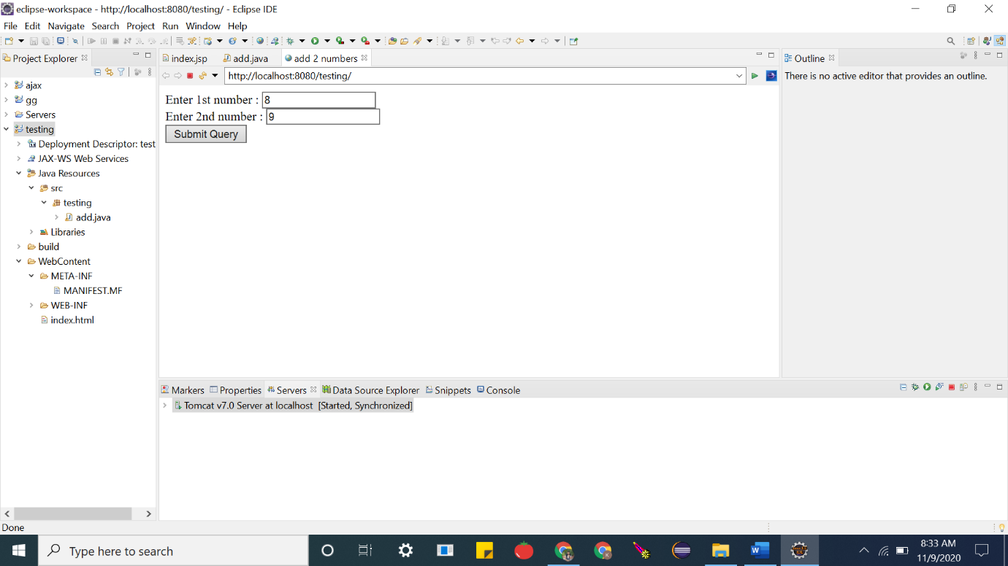

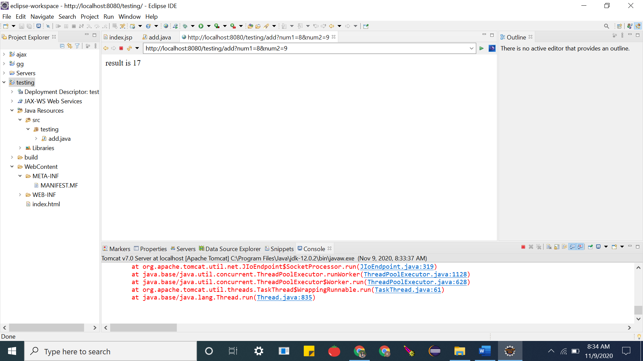

**Code:**

**ADD.JAVA**

**package testing;**

**import java.io.IOException;**

**import java.io.PrintWriter;**

**import javax.servlet.http.HttpServlet;**

**import javax.servlet.http.HttpServletRequest;**

**import javax.servlet.http.HttpServletResponse;**

**public class add extends HttpServlet {**

**public void service(HttpServletRequest req , HttpServletResponse res) throws IOException {**

**int i =Integer.parseInt(req.getParameter("num1"));**

**int j =Integer.parseInt(req.getParameter("num2"));**

**int k = i + j;**

**PrintWriter out = res.getWriter();**

**out.println("result is "+ k);**

**}**

**}**

**index.html**

<!DOCTYPE html>

<html>

<head>

<title>add 2 numbers</title>

</head>

<body>

<form action=*"add"*>

Enter 1st number : <input type=*"text"* name=*"num1"*><br>

Enter 2nd number : <input type=*"text"* name=*"num2"*><br>

<input type=*"submit"*>

</form>

</body>

</html>

**Result:**The experiment was successfully completed.